Name: ______________________

Date: _______________________

Credible Online Source Scavenger Hunt
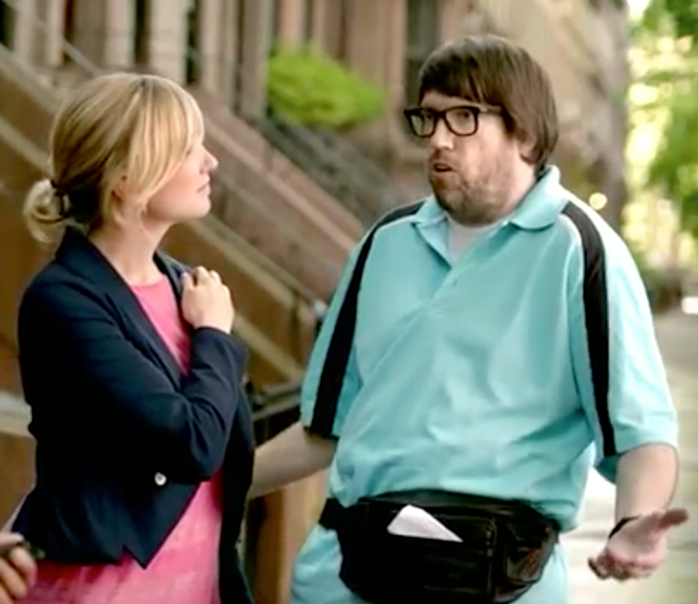
Bonjour!

You can’t always believe everything you read online because not all information posted online is completely accurate. In order to be sure that you are finding accurate information, you must be able to judge the credibility of the websites you review.

Below you will find links to some different websites. Review these websites and their content and answer the related questions.

- The Good News About Chocolate http://www.candyusa.com/FunStuff/Healthy.cfm?navItemNumber=2721

Can you find information about the nutritional value of chocolate on this website? What are some of the nutritional values of chocolate stated on this site?

Who is the publisher of this site?

Do you think this site is an authoritative source of information on the nutritional value of chocolate? Why or Why not?

- Clonaid
http://www.clonaid.com/news.php

What is the purpose of this website?

What information could you find about the author of this site?

- DHMO
http://www.dhmo.org/

What are some important facts about DHMO that are discussed on the website?

Is this site up to date? How do you know?

- The history of Boilerplate
http://www.bigredhair.com/boilerplate/

According to the website, what was the purpose for the creation of Boilerplate?

Who created and developed Boilerplate?

Who is the developer of this website?

- New Zealand Golf Game
http://www.golfcross.com/home.html

What are the pros about the shape of the ball used in this game compared to a regular golf ball?

What are some of the advantages of using goals instead of holes as in a regular golf course?

Is GolfCross real? How do you know?

- Furnetics Solution
http://www.furnetics.com/index.html

What are the goals of this company?

Who is the owner of this company?

What type of services do they provide?

- Facts about Women and Aids
http://147.129.226.1/library/research/AIDSFACTS.htm

Who is the author of this site?

What is the purpose of this site?

- A Short Introduction to the Study of Holocaust Revisionism http://www.ibiblio.org/team/history/controversy/abutz/intro.html

What does this website claim concerning the Holocaust?

Is Dr. Arthur Butz an authoritative source of information on the Holocaust? Why or Why not?

EXIT TICKET QUESTIONS:

What does it mean that a source is credible, and how can you determine the credibility of a source? How do you plan to apply this knowledge in your own research next week?

